Boston University Academy Model United Nations Conference VIII
Saturday, February 1st to Sunday, February 2nd 2020
Boston University Academy
Boston MA

Special Political and Decolonization Committee
(SPECPOL)

Background Guide

A Welcome from the Chair

Hello Delegates,
My name is Phevos Paschalidis and I will be your chair this year. My vice-chair this year will be Loeina Sooch. I am a junior at Boston University Academy and have been participating in MUN since my freshman year. This is my first year chairing, and I’m excited to share this new experience with you.
In committee, we will be simulating the Special Political and Decolonization Committee (SPECPOL). Specifically, we will be discussing the Israel-Palestine and China-Taiwan conflicts. These are both contentious and fascinating topics that impact millions of people’s daily lives and have no clear and easy solution. It will improve your experience, and the experience of all of us if you come prepared with research about these two topics, your country’s interests and goals, and potential allies. Your research will help you form a solid basis for your arguments that you should use to form practical and creative solutions to the problems at hand. If you have any questions at all, please email me at phevosp@bu.edu. In turn, I will try to make your Model UN experience the best it can be.

Regards,
Phevos Paschalidis ‘21

Committee Information
The Special Political and Decolonization Committee is one of the six main committees of the United Nations. It considers a variety of distinct issues, spanning from international cooperation in the uses of outer space to the effects of atomic radiation. One of its more important functions, however, is its oversight of decolonization in the Middle East and elsewhere. Initially, it was solely responsible for these problems of decolonization until it was merged with the Special Political Committee. Multiple more specific committees report to SPECPOL including the United Nations Relief and Works Agency for State of Palestine Refugees in the Near East (UNRWA).

Position Paper Guidelines
This committee will require a formal position paper for each of its topics (two position papers total). Chairs will review position papers, and well-written and well-researched papers are eligible for the committee’s Best Position Paper Award, as well as influencing other award determinations. Position papers are 1-2 pages in length, double-spaced, and should follow a 3-paragraph scheme: 1) Introduction to the topic, 2) delegate’s stance on the topic, and 3) delegate’s proposed action on the topic. Please write your position paper in first person, as if you are the person through whom you are speaking. If the person you are representing does not have an explicit stance on a topic, you may write about the topic using your own opinion. If you wish to receive feedback/suggestions on your position papers (before committee), please send them to your chair at least three days before the conference, and indicate that you wish to receive feedback. If you don’t want feedback, make sure to send your position paper any time before the beginning of committee - paper copies at the beginning of committee will not be accepted. Position papers should follow the following conventions on headers:

Delegate: Victor Orlov
School: Boston University Academy
Committee: Special Political and Decolonization Committee (SPECPOL)
Position: Belgium
Topic: Israel-Palestine Conflict

Topic 1: Israel-Palestine Conflict
Historical Context:
The Israel-Palestine conflict is particularly contentious because of its historic and religious roots that can be traced back to 2000 BC (History). The Old Testament, considered not only a religious document but a historical text as well, narrates the settlement of the Jewish people in this land thousands of years before the modern nation of Israel. Jerusalem was controlled by the Jewish people until the city and the surrounding regions were conquered by Roman Empire. As Christianity spread through the region and the Roman Empire, Jerusalem was controlled by an increasingly Christian authorities, especially as the Roman Empire separated into two. As part of the Eastern half, it became one of the most important Christian holy cities (called Sees). In 637 AD, however, the fifty-year old Islamic Caliphate wrested control of the city from the Byzantine Empire (BBC). Muslim rule over the city was never again doubted except for the few Christian crusades who succeeded in briefly reclaiming the city. As has been described, Jerusalem is an important religious city for all three Abrahamic religions and this status directly influences the modern day struggle as the Jewish people claim an ancient, God given right to the land and the predominantly Muslim Palestinian’s cite their thousand year old rule over the region and their own religious text as they fight for control as well (National Geographic).

The Founding of Modern Day Israel:
The history of the modern Israel-Palestinian conflict can be traced back to 1917, when Britain seized control of Palestine from the Ottomans and dedicated it to a “national home for the Jewish people.” In 1922, Britain separated this region into Transjordan (modern day Jordan) and Mandate Palestine, and restricted Jewish migration to the former. The outbreak of WWII in Europe lead to increased immigration to Mandate Palestine, and to eventual independence from British control in 1948 (UN).
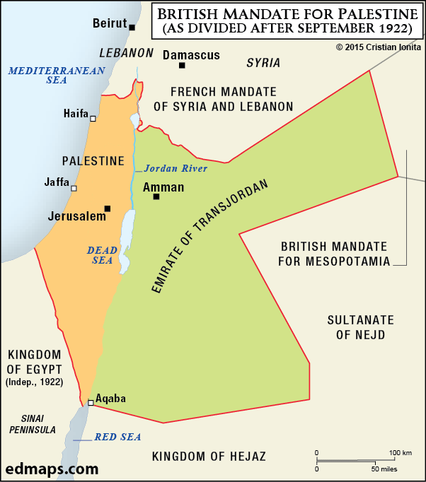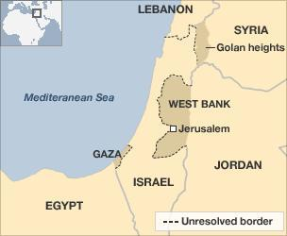
A Map of Mandate Palestine (Israel) and the Surrounding Countries and Regions Before and
After British Independence

Israel-Arab Conflicts:
A day after gaining independence, the first Arab-Israeli war broke out with Israel fighting Egypt, Jordan, Syria, and Transjordan. The resolution of this war left Israel in control of western Jerusalem. At the time, Jordan annexed the West Bank and eastern Jerusalem, and Egypt occupied Gaza. In the years following, there was continued migration into this region from Europe and from Jewish people living in the surrounding countries. This pattern of colonization continued, until 1967, when there was a fundamental shift in the power structure of this region as, during a six-day war, Israel seized control of east Jerusalem, Gaza, the West Bank, and the Golan Heights. In response to the shifting power in the region, militants of the Palestinian Liberation Organization (PLO), founded in 1964, captured and killed nine members of the Israeli Olympic Team in 1972 games in Munich (BBC). The following year, Egypt and Syria launched an unsuccessful coordinated attack against Israeli forces in the Golan Heights. Amid increasing tension, Israel invaded Lebanon in 1982 to expel PLO leadership after a failed assassination attempt of an Israeli ambassador. The same year, between 762 and 3500 Palestinian and Lebanese Shiites were massacred in refugee camps. Israel’s defense minister was deemed indirectly responsible for this massacre (Vox).

Oslo Declaration
In 1991, following decades of increasing violence and hostility, Israel, Lebanon, Syria, Jordan, and Palestinian representatives met with each other for the first time since 1949. In 1993, Prime Minister Rabin and PLO leader Yasser Arafat signed the Oslo Declaration, and outlined a plan for Palestinian self-government and an end to the Palestine uprisings. Most of these uprisings stemmed from mass boycotts and attacks between Israeli military and protesters. In November 1995, after a peace treaty with Jordan and receiving the Nobel Peace Prize, Israeli prime minister Rabin was shot by Jewish extremists who considered him too moderate in his talks with Palestine (CIA World Factbook). In the following years as peace talks broke down, a second wave of violence swept through the area, known as the second intifada (History). The 2000’s saw military operations, terrorist attacks, the construction of a barrier around the West Bank, and Israel’s subsequent withdrawal and invasions Gaza. Hamas, a Palestinian Islamic militant organization, uses Gaza as a launching point for rockets and Israel responds with military campaigns and incursions. A long-term ceasefire or any settlement has not yet been reached and terrorist attacks and civilian deaths have continued (CNN).

Questions to Consider
- What is your country’s position on the Israel-Palestine conflict?
- Does Israel, Palestine (or both) deserves access to the land under question (Gaza and the West Bank)? Why?
- What has your country done to assist either Israelis or Palestinians?
- What is your country’s position on Palestine’s bid for UN membership?
- What will it take to appease radicals both in Israel and surrounding it?

Bloc Positions
Lebanon, Jordan, Syria, Egypt, Iran, Iraq, Turkey:
Pro-Palestine forces and against Israeli colonization and occupation of the West Bank and Gaza
NATO:
Historically pro-Israel but shifting recently to become more critical of Israel’s actions in the Middle East
USA:
Historically pro-Israel and even more so under current president Trump.

Further Research
https://history.state.gov/milestones/1945-1952/arab-israeli-war
https://www.bbc.com/news/world-middle-east-29123668
https://www.vox.com/2018/11/20/18080066/israel-palestine-intifadas-first-second
https://www.history.com/news/why-jews-and-muslims-both-have-religious-claims-on-jerusalem
https://www.meforum.org/490/the-muslim-claim-to-jerusalem
https://www.edmaps.com/html/palestine_in_ten_maps.html
SPECPOL Resolutions: http://un.org/en/ga/fourth/.

Topic 2: Taiwan-China Conflict
Taiwan is an island located off the southern coast of China. Officially known as the Republic of China, Taiwan has been independently governed from China (People’s Republic of China) since 1949.
Taiwan, home to twenty three million people, has its own democratically elected government. Political leaders from various countries have differing views on Taiwan’s relations with China (CFR).

The History of Taiwan
Taiwan was a Dutch colony from 1624 to 1662, and ruled by the Chinese Qing Dynasty from 1683 to 1895. The Qing dynasty ceded Taiwan after the Japanese victory in the first Sino-Japanese War (Treaty of Shimonoseki). Taiwan was under Japanese rule from 1895 to 1945. With the end of World War II and Japan’s defeat, Japan ceded Taiwan back to China.
In 1949, the Nationalist government of mainland China was defeated by the Communist Party led by Mao Zedong in the Chinese Civil War. Upon defeat, the Nationalist government retreated to Taiwan still claiming to be the true national government of China. Political leaders from the Nationalist Government in Taiwan represented China in the United Nations as the Republic of China until 1971 when the Communist Party government of mainland China took the spot and the Nationalist government based in Taiwan lost their international standing. The Nationalist party, now called the Kuomintang, governed Taiwan from 1949 to 1987. Founded in 1986, the Democratic Progressive Party, the rival of the Kuomintang, considers Taiwan as an independent country (ie not a part of China). The Kuomintang holds the opinion that Taiwan is not independent from China and is actually a Chinese province.

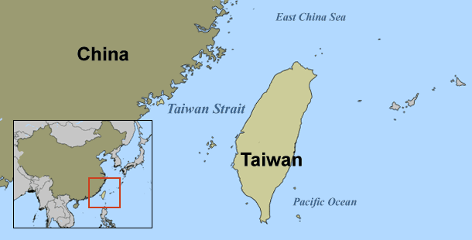
Modern Day Complications
After years of hostility, relations between China and Taiwan started improving in the 1980s. It was during this time that China put forward a formula known as “one country, two systems” which would give Taiwan significant autonomy if it considered itself part of China (CFR). The Taiwanese government rejected China’s proposed formula.
In 2000, Beijing became alarmed when Chen Shui-bian of the Democratic Progressive Party, who had openly backed Taiwanese independence from China, won the Taiwanese presidential election. When Mr. Chen was re-elected as President in 2004, China passed an anti-secession law, making it ‘illegal’ to secede from China, in response (Britannica). In 2008, Ma Ying-jeou of the Kuomintang was elected president and sought to improve relations with China. Then, in the presidential elections of 2016, Tsai Ing-wen, a supporter of Taiwanese independence from China, defeated Kuomintang party candidate Eric Chu.
Throughout 2018 and 2019, China has pressured international companies to list Taiwan as a part of China on their websites and threatening to block them for doing business in China if they fail to comply (BBC).

The Cairo Declaration
During World War II, Chiang Kai-Shek, the leader of the Nationalist party that ultimately retreated to Taiwan, met with American President Franklin Roosevelt and British Prime Minister Winston Churchill in Cairo to discuss the progress of war. The Cairo Declaration states that, “…Formosa [Taiwan], and the Pescadores [the Penghu Islands], shall be restored to the Republic of China [Taiwan]…” (The Official Website of the Republic of China). The declaration developed ideas from the 1941 Atlantic Charter. This document states that territories taken from China by Japan, this includes Taiwan, were to be returned to China (U.S. Department of State).

Questions to Consider
- What is your country’s position on the Taiwan-China conflict?
- Does Taiwan or China deserve the ownership of Taiwan? Why? Could and should the “one country, two systems” plan be considered again?
- What has your country done to assist either Taiwan or China in this dispute?
- Does Taiwan deserve to be a member of the United Nations?
Bloc Positions
Lebanon, Iran, Syria, Egypt, Jordan:
Allies of China. Iraq joins the ranks of China’s Belt and Road. Beijing is set to be a major player as Syria rebuilds. Chinese investments in Egyptian infrastructure also have the potential to support the Egyptian regime in a way that insulates the leadership from popular pressure. China is exploring a new paradigm of relations with Jordan (The Diplomat). Jordan is the only Mideast country with a special trade office in the Republic of China (Taiwan Today).
Iran:
China has become the dominant external player in Iran’s economy (CNA).
Turkey:
The US policy towards Taiwan was based on preventing the spread of communism in Asia. Turkey recognized the Republic of China on Taiwan (ROC) instead of People's Republic of China (PRC) as a natural result of its policy against Communist expansion (Kasım, Kamer).
USA:
Washington does not recognize the Republic of China, but at the same time continues relations with Taiwan through military weapons sales that anger China (The Atlantic).

Further Research
https://www.bbc.com/news/world-asia-34729538
https://www.cfr.org/backgrounder/china-taiwan-relations
https://www.britannica.com/place/Taiwan/Government-and-society
https://guidetotaipei.com/article/is-taiwan-part-of-china
https://www.taiwan.gov.tw/content_3.php
https://2001-2009.state.gov/r/pa/ho/time/wwii/107184.htm

